***FINAL EXAM***

***Student Name: Basavraj Nagappa Jaliminche***

***Student Id: 8800149***

***PROGRAM: Reporting Systems and Database Development (1517)***

***Course Name: Relational Databases PROG 8590***

**Q 1**

1. **Write an anonymous block using PL/SQL (program) to determine the order status of a customer. The program will search using a customer's ID and determine how many orders the customer has made. - If the customer has 3 or more orders, create a message telling the user what this customer is a ‘Preferred customer’. - If the customer has less than 3 orders, inform the user that this is a ‘Normal customer’. - If the customer has no orders yet, inform the user that the status is ‘No orders’.**
2. **Run the program 3 times hardcoding in a search for customer id 145, 111 and 155. You only need to submit one version of your code, but include 3 outputs.**

**Answer:**

--Anonymous block

DECLARE -- declaration

v_cid number:=145; -- declarinng the value with custmarid=145

v_ordStatus number;

BEGIN --execution section

SELECT COUNT(*) INTO v_ordStatus

FROM OEHR_ORDERS

WHERE CUSTOMER_ID = v_cid;

IF(v_ordStatus >= 3)

THEN --IF condition

DBMS_OUTPUT.put_line('Preferred customer');

ELSIF(v_ordStatus BETWEEN 1 and 3) THEN -- condition

DBMS_OUTPUT.put_line('Normal customer');

ELSE --if all other condition fails

DBMS_OUTPUT.put_line('No orders');

END IF; --end if statement

EXCEPTION --exception handling section section

WHEN OTHERS THEN

DBMS_OUTPUT.put_line(SQLERRM);--error message displaying

END; --end

Screenshots:

When Custamar id=145

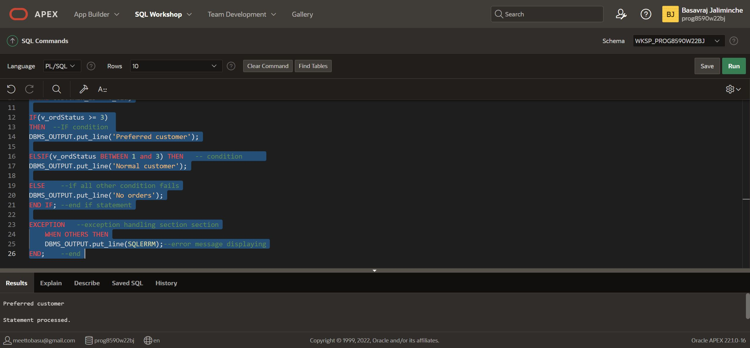

**When Custamar id=111**

--Anonymous block

DECLARE -- declaration

v_cid number:=111; -- declarinng the value with custmarid=145

v_ordStatus number;

BEGIN --execution section

SELECT COUNT(*) INTO v_ordStatus

FROM OEHR_ORDERS

WHERE CUSTOMER_ID = v_cid;

IF(v_ordStatus >= 3)

THEN --IF condition

DBMS_OUTPUT.put_line('Preferred customer');

ELSIF(v_ordStatus BETWEEN 1 and 3) THEN -- condition

DBMS_OUTPUT.put_line('Normal customer');

ELSE --if all other condition fails

DBMS_OUTPUT.put_line('No orders');

END IF; --end if statement

EXCEPTION --exception handling section section

WHEN OTHERS THEN

DBMS_OUTPUT.put_line(SQLERRM);--error message displaying

END; --end

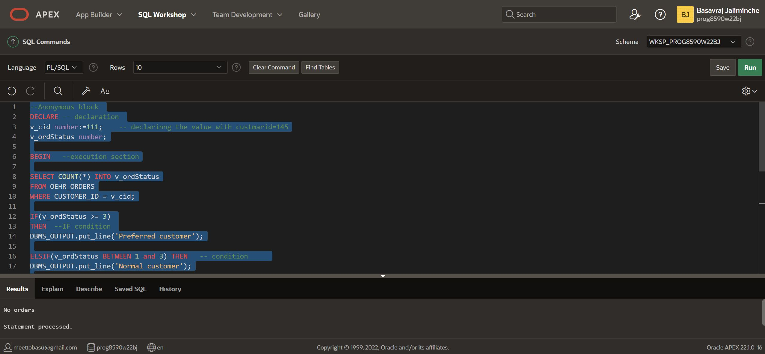

**When custamar id=155**

--Anonymous block

DECLARE -- declaration

v_cid number:=155; -- declarinng the value with custmarid=145

v_ordStatus number;

BEGIN --execution section

SELECT COUNT(*) INTO v_ordStatus

FROM OEHR_ORDERS

WHERE CUSTOMER_ID = v_cid;

IF(v_ordStatus >= 3)

THEN --IF condition

DBMS_OUTPUT.put_line('Preferred customer');

ELSIF(v_ordStatus BETWEEN 1 and 3) THEN -- condition

DBMS_OUTPUT.put_line('Normal customer');

ELSE --if all other condition fails

DBMS_OUTPUT.put_line('No orders');

END IF; --end if statement

EXCEPTION --exception handling section section

WHEN OTHERS THEN

DBMS_OUTPUT.put_line(SQLERRM);--error message displaying

END; --end

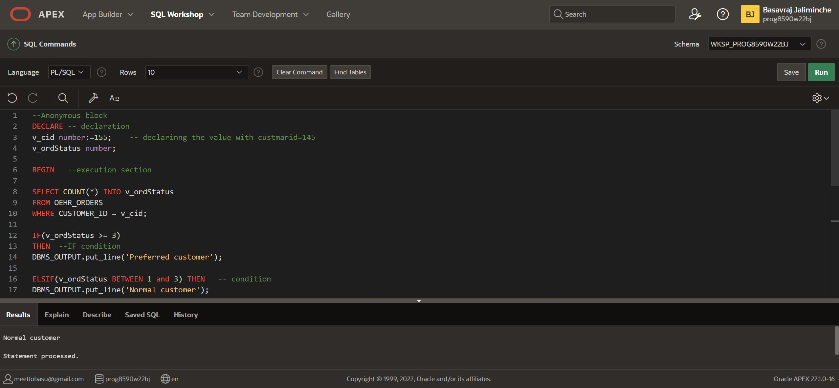

**Question 2: [7 Marks] 1- Modify the written program in Question1 to determine the status of a customer by defining a function that takes into the customer Id as Input parameter and return the customer status as Output parameter. 2- Run the program hardcoding in a search for the customer id 155.**

**Answer:**

**-- Function Body**

**CREATE OR REPLACE FUNCTION customerStatus(cid NUMBER)**

**RETURN NUMBER**

**IS --function return datatype**

**--variable**

**v_num NUMBER;**

**BEGIN**

**-- Query for checking count of employee in dept**

**SELECT COUNT(*) INTO v_num**

**FROM OEHR_ORDERS**

**WHERE CUSTOMER_ID = cid;**

**RETURN v_num;**

**EXCEPTION**

**WHEN NO_DATA_FOUND THEN**

**DBMS_OUTPUT.PUT_LINE('Customer ID not exist');**

**RETURN v_num;**

**END;**

--Anonymous Block

DECLARE

v_orderStatus number;

cust_id number := 155;

BEGIN

v_orderStatus := customerStatus(cust_id); -- calling function and assigning return value to variable

--check condition for status

IF(v_orderStatus >= 3) THEN --IF condition for order status

DBMS_OUTPUT.put_line('Preferred customer');

ELSIF(v_orderStatus BETWEEN 1 AND 2) THEN --ELSE-IF condition for order status

DBMS_OUTPUT.put_line('Normal customer');

ELSE ----ELSE condition if all other condition fails

DBMS_OUTPUT.put_line('No orders');

END IF; --end if statement

END; -- end Anonymous Block

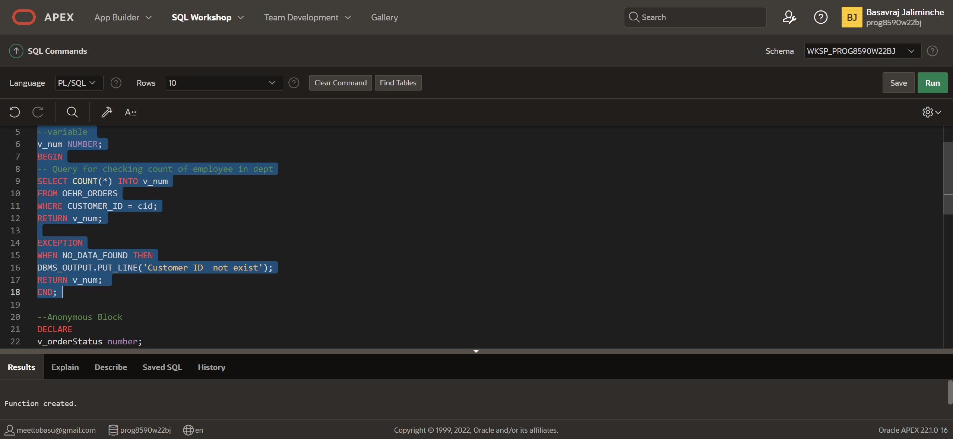

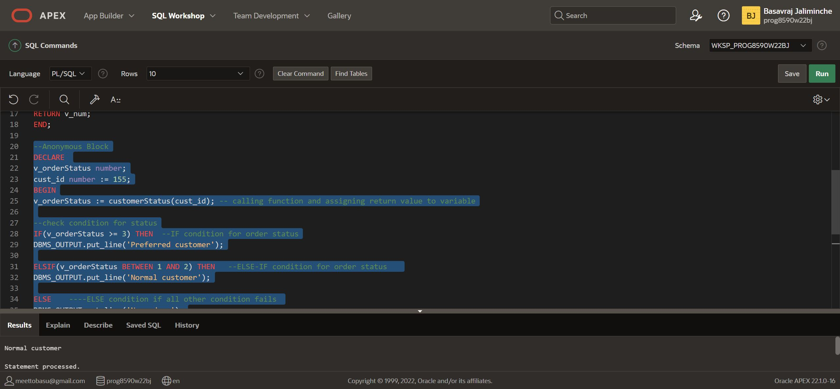

**Q.3 Write an anonymous block using PL/SQL (program) to output the number of employees in each department group by city from OEHR_LOCATIONS and save it in a Varray of 30 elements. To do this, please follow these steps: 1- Define a record that holds the department name, the number of employees and the city. [5 pts] 2- Define the Varray type and the varray variable [3 pts] 3- Define the cursor to fetch the data [5 pts] 4- Load data into the varray [5 pts] and display the result [2 pts] Expected result:**

London: Department [department_name] has 99 employee(s)

Seattle: Department [department_name] has 99 employee(s)

Department [department_name] has 99 employee(s)

**Answer:**

**DECLARE**

**--record that holds the department name ,number of employess...**

**TYPE r_department_detail IS RECORD (**

**dept_name OEHR_DEPARTMENTS.DEPARTMENT_NAME%TYPE,**

**dept_emp number,**

**dept_city OEHR_LOCATIONS.CITY%TYPE**

**);**

**-- VARRAY TYPE**

**TYPE t_dept_varray IS VARRAY(30) OF r_department_detail;**

**-- VARRAY VARIABLE**

**v_dept t_department_varray:=t_department_varray();-- empty varray**

**-- CURSOR TO FETCH DATA FROM OEHR_EMPLOYEES**

**CURSOR c_department IS**

**SELECT COUNT(*) EMPLOYEE_COUNT, DEPARTMENT_NAME, CITY**

**FROM**

**OEHR_EMPLOYEES OE**

**LEFT JOIN**

**OEHR_DEPARTMENTS OD**

**ON OE.DEPARTMENT_ID = OD.DEPARTMENT_ID**

**LEFT JOIN**

**OEHR_LOCATIONS OL**

**ON OD.LOCATION_ID = OL.LOCATION_ID**

**GROUP BY DEPARTMENT_NAME, CITY;**

**BEGIN**

**-- Loading data**

**FOR my_data IN c_department LOOP**

**v_department.EXTEND;**

**v_department(v_department.LAST).dept_emp:=my_data.EMPLOYEE_COUNT;**

**v_department(v_department.LAST).dept_name:=my_data.DEPARTMENT_NAME;**

**v_department(v_department.LAST).dept_city:=my_data.CITY;**

**END LOOP;**

**DBMS_OUTPUT.put_line(v_department.COUNT);**

**FOR my_index IN v_department.FIRST..v_department.L**

**FOR my_index IN v_department.FIRST..v_department.LAST LOOP**

**DBMS_OUTPUT.put_line(v_department(my_index).dept_city||' : '|| v_department(my_index).dept_name||' has '|| v_department(my_index).dept_emp||' employee(s)');**

**END LOOP;**

**END;**

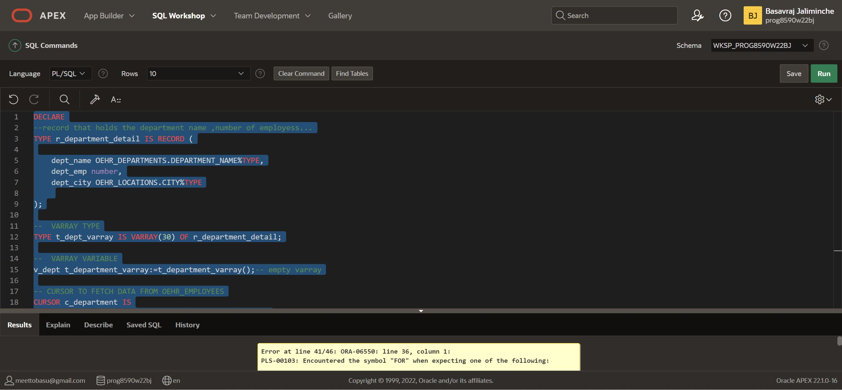

**Q-4**

1. **Create a table named INVENTORY which has five columns: INVENTORY_ID NUMBER(6) [Primary key], ITEM_NAME VARCHAR2(255), QUANTITY NUMBER, PRICE NUMBER, ITEM_SIZE VARCHAR(255), INVENTORY_VALUE NUMBER. [2 pts]**
2. **Create a trigger that only allows an insert to complete if the SIZE value is one of the following (and any case variations): S, M, L, XL, small, medium, large, extra-large. If an invalid input is attempted to be inserted, reject the insert and raise an application error that states 'Please enter for SIZE only: S, M, L, XL, small, medium, large or extra-large'. [8 pts]**
3. **Insert into the INVENTORY table (1, 'Web Shooter, 2, 19.00, 's', 38.00) Insert into the INVENTORY table (2, 'Fantasticar', 4, 3000.00, 'very big', 12000.00) Insert into the INVENTORY table (3, 'Mjolnir', 1, 100.00, 'medium', 100.00) Run a SELECT * statement on the INVENTORY table. [3 pts]**
4. **DELETE all rows created in Question 4-3 from the INVENTORY table. [2 pts]**
5. **Create an insert command to insert the following into the table INVENTORY: (42, 'LMD', 2, 199.99, 'M'). Run a SELECT * statement on the INVENTORY table. You will notice the VALUE column for the item LMD is missing. [2 pts]**
6. **Create a trigger which fires on inserts or updates and fills in the INVENTORY_VALUE column as Quantity multiplied by Price. [6 pts]**

**Answer:**